MINUTES OF THE FIRST PROJECT BOARD MEETING OF LDCF PROJECT, “ASSISTING LEAST DEVELOPED COUNTRIES (LDCs) WITH COUNTRY-DRIVEN PROCESSES TO ADVANCE NATIONAL ADAPTATION PLANS (NAPs)”
16-17 August, 2013, Bangkok, Thailand
PROJECT BOARD MEMBERS:
Ms. Ermira Fida, UNEP (co-chair)
Mr. Pradeep Kurukulasuriya, UNDP (co-chair)
Ms. Pepetua Latasi, LEG
Mr. Youssef Nassef, UNFCCC
Ms. Marina Maiero, WHO
Mr. Angus Mackay, UNITAR
Mr. David Brown, FAO
Mr. Alex Simalabwi, GWP
ALSO PRESENT:
Mr. Paul Desanker, UNFCCC
Mr. Mozaharul Alam, UNEP
Mr. Prakash Bista, UNEP
Mr. Paul Steele, UNDP
Ms. Andrea Egan, UNDP (via Skype)
Mr. Ole Vestergaard, UNEP-WCMC (via Skype)
Ms. Mariana Simões, USAID ADAPT Asia-Pacific (via Skype)
Mr. Till Below, GIZ (via Skype)
Mr. Richard Klein, PROVIA (via Skype)
ABSENT:
Ms. Bonizella Biagini, GEF Secretariat
Mr. Prakash Mathema, LDC Group Chair
Mr. Gernot Laganda, IFAD
Two representatives from countries supported by GSP initiative

KEY BOARD DECISIONS:
- The GSP is open to support all LDCs that request assistance with their country specific NAP process. The GSP will provide TA, advisory services, training, leverage partnerships. To-date, a number of countries (17) have formally requested assistance from the GSP. The GSP team will contact each country to determine their specific needs, in addition to the responses in the survey, and agree on a mechanism for the countries to receive the requisite support. Should additional requests from countries emerge, the GSP will work with the LEG and its partners to determine an effective means of supporting the requests through multiple approaches.
- The GSP will provide support to all LDCs through Outcomes 2 and 3, as well as specific one-on-one support (based on specific requests) to countries that request such support under Outcome 1 of the LDCF council approved project.
- Regarding the survey that was carried out by the GSP to inform planning decisions on how support will be provided, the project team will need to further analyze the respondents’ data, as well as follow up with countries for additional information. This aggregate information should be used to inform planning of activities under the GSP over the course of the project implementation period.
- The survey results should not be made public given the limited sample and selection bias of the survey. If it is released, it is important that all caveats relating to the survey are made clear.
- The Board members decided that the GSP should prepare an inventory of the tools and good practices that countries may find useful in their respective NAP process without overwhelming the countries, and to assist in making existing tools and guidelines more practical (on an applied level) at the national level.
- GSP should seek to coordinate with partner agencies to ensure all available support activities to countries that are relevant for NAPs are leveraged to support as many LDCs as possible. Coordination with all relevant partners at the national level, including representatives of donor countries at the country level, should be facilitated.
- Given the supportive nature of the GSP, the project itself (including country-level trainings and workshops) will not directly undertake NAP preparation activities for the country. GSP, one among many supportive mechanisms available to LDCs, can be used to build countries’ knowledge and skills to advance their NAPS.
- The board agreed that the GSP will provide regular updates to the LEG on activities conducted including feedback from countries assisted.
- The Board reviewed the logframe and work plan and recommended refinements to improve the focus of GSP activities. For amendments and changes to the Log Frame and Work Plan, please see Annex 1.
- The Board agreed to reconvene at COP19 in Warsaw, Poland to take stock of progress.
SUMMARY OF THE FIRST BOARD MEETING OF NATIONAL ADAPTATION PLAN GLOBAL SUPPORT PROGRAMME (NAP GSP)
DAY 1
- The first Board meeting for NAP GSP was held in Bangkok, Thailand from 16-17 August 2013.
- Mr. Pradeep Kurukulasuriya, UNDP convened the Board meeting and outlined the objectives of the meeting, namely,
  - to provide the project team of NAP GSP with sufficient guidance to be able to carry out its work as outlined in the Work Plan (Results Framework and Work Plan for NAP GSP are made available in Annex I of this document);
  - to revisit the Work Plan for the project, in particular provide specific direction for this year’s activities including timeline;
  - to review partner organizations’ support offers and/or current work in LDCs related to NAP;
  - to review the survey recently conducted by the GSP on identifying priority areas of support that countries are requesting to help them start or advance the NAP process; and
  - to discuss the number of countries that will be supported by the GSP, and if required, come up with a selection criteria for countries to receive one-on-one support (Outcome 1 of the results framework and Work Plan).
  - To discuss the content and scope of support that will benefit all LDCs (outcomes 2 and 3 of the results framework and Work Plan), which will be delivered through regional workshops.
- There were no amendments/additions and the agenda was adopted. Mr. Kurukulasuriya suggested rotating chairpersons for the Board meeting, assuming the role of chairperson for the morning session and called for volunteers for different sessions. The following persons chaired the different sessions:
  - Mr. Pradeep Kurukulasuriya, UNDP – Session I;
  - Ms. Ermira Fida, UNEP – Session II;
  - Mr. Youssef Nassef, UNFCCC – Session III – Partnering organizations’ presentations;
  - Mr. David Brown, FAO – Session III – Country selection;
  - Mr. Angus Mackay, UNITAR – Session IV.
SESSION I
Update on NAP GSP and work of Partner Agencies
- On behalf of UNEP and UNDP, Ms. Fida outlined the progress to date on operationalizing the NAP GSP since the NAP Expo at the Bonn Climate Change Conference in June 2013. She noted in particular that:
  - a detailed Work Plan had been developed;
  - the GSP project was internalized and made operational in both lead agencies (UNDP and UNEP);
  - Terms of Reference (ToRs) for GSP Project team, to be co-located in the UN Premises in Bangkok where both UNDP and UNEP have Regional offices, were developed;
    - Project team to consist of a Lead Technical Specialist to be recruited by UNDP (recruitment process already started), a Technical Specialist to be recruited by UNEP and a Project Assistant ;
  - a survey to help the project team determine priority areas of support that countries are requesting to help them start or advance the NAP process was undertaken (with the input of all partners represented in the Board and special support from UNFCCC Secretariat and UNITAR) in August 2013 and preliminary results were available for the Board meeting.
  - discussions with GIZ and other partners have taken place
- Clarification was provided on the GSP, with Mr. Kurukulasuriya stating that project was not classified as an enabling activity by GEF Council, but rather a Medium Sized Project (MSP). It is closely aligned with a number of baseline projects that are outlined in the project document, linkages to which the project team will need to maintain. The GSP was endorsed by GEF CEO in June, and that the budget was fully operational, enabling work of the GSP to be started immediately. Ms. Fida further stated, in terms of financing through the LDCF for the NAPs, that NAP can be implemented as a stand-alone process by the LDCs, or be integrated into NAPA implementation. She then opened the floor for partner agencies to comment on what was being done in their respective work related to the NAP process.
UNFCCC
- Mr. Paul Desanker and Mr. Youssef Nassef of UNFCCC highlighted the LEG’s work on expanding coverage for NAPs in their regional workshops, as well as engaging with partners on water and health supplements. Mr. Desanker and Mr. Nassef further noted that the COP in November 2013 will review the NAP guidelines and it is important to watch it closely as any changes will have direct impact on the work of GSP.
FAO
- Mr. David Brown of FAO described the work of the organization in support of the NAP process in LDCs. He stated that several adaptation framework projects were being implemented by FAO particularly on agriculture and food security aspects of NAP and said he looked forward to greater synergies in capacity building efforts.
UNITAR
- Mr. Angus Mackay of UNITAR outlined the agency’s work towards supporting countries with their NAP process. He then highlighted two areas in which UNITAR can provide support:
  - UN CC:Learn – Mr. Mackay explained that UN CC:Learn had already compiled training materials not only on adaptation, but all climate change related products from all across the UN;
  - National support was provided for five countries to date on developing skills on cross-governmental processes, and for middle/senior level bureaucrats, etc. A second phase of the project (not yet signed) would provide support on NAP development.

WHO
- Ms. Marina Maiero of WHO stated that the agency had commenced an initiative to support the development of health component specific NAP frameworks in 32 countries in Africa. She indicated that WHO will soon be rolling out additional technical assistance to other regions. WHO was said to be very supportive of the GSP for NAP, and the tools that the agency has developed are ready for dissemination through the various initiatives conducted under the auspices of the GSP. Ms. Maiero also expressed the agency’s willingness for collaboration with the GSP moving forwards.
- A general consensus was voiced by the Board members in support of greater synergies in initiatives and efforts from different agencies and partners, so as not to reinvent the wheel when assisting countries with their NAP process.
First Review of the Project Work Plan
- Mr. Mozaharul Alam of UNEP presented a draft Work Plan for the GSP project (see Annex I). Mr. Alam indicated that the project Objective and Outcomes were approved by the GEF and could not be changed at this point. However, the outputs were dependent on a review of their continued relevance, and the Board could approve amendments based on consensus.

Based on the first reading of the draft Work Plan, the Board then entered into a discussion focusing on the type of support that countries are likely to request (based on feedback from LDCs to date), which countries have currently requested support, and the fact that based on intelligence from several GEF-Agencies and others, certain countries are already well into developing their NAPs.
The Board also noted the need to revisit sequencing and timing of the different outputs and activities.
It was reiterated that the GSP would provide support to all LDCs through Outcomes 2 and 3, as well as specific one-on-one support (based on specific requests) to select countries for Outcome 1. The Board was provided a list of these specific country requests based on feedback received from countries at the recently concluded Kigali LEG workshop (made available under Annex III of this document).
Mr. Brown flagged the issue of trans-boundary impacts which may also need to be reflected in the NAP process of countries (e.g. watershed adaptation planning in one country can have maladaptation consequences in another neighboring country, etc.) and that they should be addressed. Mr. Kurukulasuriya agreed that sufficient guidance needed to be provided to the project team, including the need for knowledge products as guidance on such issues as well as awareness raising and advisory support.

When queried about the number of countries supported through the GSP, Mr. Kurukulasuriya stressed that individual support cannot be provided to all LDCs through the GSP, given the amount of funding available in the project. However, Mr. Kurukulasuriya stressed that as and when additional demand for support was evident, the GSP can work towards helping countries to link to other initiatives supported by different agencies, assistance can be provided on the back of ongoing support to countries with LDCF/SCCF/AF financed projects besides the dedicated support that the GSP will itself provide. He stressed that as there were a number of ongoing initiatives that the GSP builds on, it should be possible to identify value added initiatives that the GSP support that may not require substantial technical assistance and/or funding.
Ms. Pepetua Latasi of LEG informed that the LEG was actively developing a web-based portal, NAP Central, to be launched by Warsaw (November 2013). Ms. Maiero suggested a coordinated effort, especially on web-based tools and platforms such that existing tools can be utilized. Mr. Kurukulasuriya and Mr. Alam agreed on the need for greater coordination and that guidance needed to be provided to the project team to avoid replicating initiatives, rather to compliment ongoing ones.
Due to timing of Session III that included other partner agencies joining via Skype for the Board meeting, further discussions on Work Plan was scheduled for Session IV of the meeting the next day.
SESSION II
NAP Survey Report, Preliminary Results

- Ms. Andrea Egan of UNDP (AE) presented the preliminary results of a survey that was undertaken to inform the design of outputs and activities under NAP GSP.
The survey was administered for 3 weeks using an online tool and closed on the 12th of August 2013. Survey questions were mostly multiple-choice in nature, with some open ended questions for specificity. ‘Hover-texts’ were made available to define terms for clarifications, listed in Annex 2 of the survey. UNITAR and UNDP staff assisted with translation into French and Portuguese.

Ms. Egan reported that there were more than 150 respondents from around 56 countries, of which 40 were LDCs. 80% of responses were in English, almost 5% in Portuguese and the rest in French. Ms. Egan noted that of the respondents, most were project coordinators or field officers. As of 12 August, 2013, 78.9% of respondents were male, 21.1% were female. Ms. Egan further highlighted the preliminary results and that there was a need for further analysis to arrive at a meaningful set of results.
Comments and discussions mainly focused on presentation and disaggregation of results specific to LDCs and a need to cluster them based on ranking of highest needs. Mr. Desanker noted that a need for Element D on Reporting, Monitoring and Evaluation of NAP ranking high on the country need for support was interesting, as it was the newest concept.
Mr. Kurukulasuriya suggested a ‘cut-off’ point to guide the project team so that the GSP is not stretched in terms of the areas that it provides support in.
Ms. Fida noted results indicating two major areas of support requested, namely technical support and awareness-raising, as good indicators of guidance for the project team.
The Board agreed that the project team will need to further analyze the data, as well as follow up with countries for additional information. This aggregate information should be used to inform activities that are developed over the course of the project implementation period. The Board also agreed that the survey results should not made public given the limited sample and selection bias of the survey.
Mr. Mackay suggested a repeat of the survey at the end of the GSP to compare results.
SESSION III
Presentations from Partner Organizations
UNEP-WCMC
- Mr. Ole Vestergaard from UNEP-WCMC presented the work of the partner organization related to NAP, focusing on Ecosystem based Adapation (EbA) it is carrying out. Mr. Vestergaard outlined UNEP-WCMC’s programme in mainstreaming EbA into national adaptation planning; the innovative funding for EbA; products on sharing knowledge (REGATTA, APAN, WARN CC, etc.); Vulnerability Impact Assessment (VIA) and EbA M&E.
Discussions centered on how EbA M&E can be applied to NAP, as there are two distinct references to EbA approach in the NAP guidelines. Mr. Brown indicated FAO is currently implementing EbA for fishery supplement, and major issues surrounded coordination amongst different ministries. VIA, he noted could prove useful in the long run if points are communicated clearly. Ms. Fida noted that there was a growing interest from countries on EbA despite barriers and its long term perspective is relevant to the NAPs therefore it is expected that countries will seek support on the EbA in the NAP context. . Mr. Kurukulasuriya added that in the context of GSP, countries would want to advance their NAPs, including all elements relevant to NAPs. In that regard, there was a need to leverage opportunities from different capacity building projects to help bridge the ‘connecting’ projects.
USAID ADAPT Asia-Pacific
- Ms. Mariana Simões of USAID’s ADAPT Asia Pacific Programme presented the work of a joint USAID-UNDP financed capacity-building programme on Economics of Adaptation, which is focused on strengthening capacities in countries to apply cost-benefit analysis of adaptation projects. It also is focused on developing technical capacities of relevant persons in Planning and Finance Ministries to undertake economic assessments of the costs and benefits of adaptation in key sectors such as water and agriculture. The programme, based on a series of regional and in-country training sessions, applied research and analysis is active in a number of LDCs that are likely to also want to advance their NAPs. Ms. Simões explained that this is a two year programme and the first training workshop (focused on methods and data for understanding the economics of adaptation) was already held. Country teams are now preparing to receive the second module of training on watershed and agriculture management, utilizing in-country data. Each team has been assigned a local, recognized economist as a mentor who provides additional technical support to the team members. The second training workshop (on applying methods in economics to estimate the costs and benefits of adaptation), Ms. Simões noted would involve a higher level statistical and mathematical analysis and would eventually bring in a sectoral analysis aspect. These are all relevant pieces of information that countries will need to consider in their advancements of the NAP process.
Discussions centered on further clarification of the programme and Ms. Simões and Mr. Kurukulasuriya clarified that all the work is done at a practical level, developing skills that are useful to technical officers in key line Ministries. Furthermore, there is plan in motion to include the training material on available learning sites (which are accessible to anyone, free of charge). The programme is contemplating converting the material developed into a university curriculum. Mr. Kurukulasuriya mentioned regional institutions, e.g. AIT, UNU, were engaged as they already have ongoing relevant graduate and professional level courses that could absorb a module on the economics of adaptation. Mr. Kurukulasuriya further noted that there was interest by UNDP and the Global Water Partnership to replicate the approach used in this programme in other regions, particularly Africa.
GIZ
- Mr. Till Below of GIZ started with a background of GIZ’s work in climate change adaptation and outlined the organization’s work in NAP related activities. Mr. Below explained GIZ’s support to countries that included funding for preparation of NAPs, and the use of a tool for Element A called Smart National Adaptation Planning (SNAP) tool, M&E Adapt – focusing on Element D, and capacity development support on climate finance, etc. Support is provided in form of conceptual work, development of methods, and capacity development support to partner countries.
SNAP was introduced as an entry point for NAP in terms of guidance through a 1-2 day stakeholder event based on 7 success factors drawn up by GIZ for NAP. It includes 21 questions and charts comparing present situation vs. country goals, closely following the suggested modality of LEG NAP guidelines. It further provides nationally-specific sequential steps to building capacity. Mr. Below further explained Mauritania and Tunisia were receiving such support from GIZ, with Togo, Burundi, and Cambodia under consideration.
M&E Adapt applies three pillars of support, namely, frameworks for M&E systems; direct support to countries in operationalizing them; and capacity development and knowledge sharing.
Discussions that followed included request for clarification on the 7 ‘success factors’ used for SNAP and methodology behind it, how likely was a 1-2 day stakeholder consultation to gather such information, given complicated relationships between ministries and stakeholders, and the value added of SNAP with respect to the existing NAP technical guidelines and how it would support the country-driven approach.
Mr. Below clarified that a full assessment of SNAP hasn’t yet been completed but was confident that with 21 basic questions administered online prior to the consultation, information should be easy to gather. Mr. Kurukulasuriya suggested SNAP serves as a gap analysis tool and GSP should leverage it if it works well in the context of NAPs.
Action:
- Mr. Below to send fact sheet explaining the success factors and SNAP tool.
- Mr. Kurukulasuriya to discuss with Mr. Below in Siem Reap during the LEG workshop on Adaptation from 20-24 August 2013 to discuss further.
PROVIA SEI
- Mr. Richard Klein of PROVIA provided a background on the organization along with activities related to NAPs, focusing on VIA, namely: international research on VIA; scientific information of VIA to UNFCCC; biennial conference to improve coherence of VIA; and improving quality of VIA by revising guidance on research methods. Furthermore, Mr. Klein stated that PROVIA has developed summary documents to connect PROVIA documents (that provide guidance through a set of decision tree, tasks and methods to questions countries want answered) to NAP technical guidelines and an interactive, web-based consultation tool was about to be launched. He stated that PROVIA documents and NAP technical guidelines are complimentary to one another.
Discussions ensued on how PROVIA can help with countries’ request on gap analysis related support, vision for NAPs and capacity building. A question was also raised as to the difference between e-consultation and summary documents. Mr. Klein explained that support was provided in steps: guidance that helps in identifying gaps; PROVIA can help country be systematic about gap identification. He explained that the summary document provides a map for countries to proceed towards VIA, and the e-consultation is an electronic, interactive version of the summary document. Additional tools/documents can be developed that can be more explicit about mainstreaming adaptation to development.
ACTION:
- Mr. Klein will send contact details on approximately 10 persons (authors of the guidance) who can help with country level support.
UNDP/UNEP PEI
- Mr. Paul Steele of UNDP provided an overview of the UNEP-UNDP project on Policy Environment Initiative (PEI) and an associated tool, Climate Public Expenditure and Institutional Review (CPEIR). Mr. Steele explained that PEI was successful in working with different ministries and supporting a NAP type process in a number of countries in Asia. Mr. Steele highlighted that the CPEIR related work, which is an expenditure mapping tool, helps to raise awareness of climate change related issues especially within the Ministry of Finance. Mr. Steele explained that in many instances, countries are actually spending more domestic resources on climate change related activities than donor funded projects. CPEIR helps systematically code a country’s climate related expenditures on a year to year basis.
Discussions included an observation that some countries are already mainstreaming climate change adaptation through different approaches. A UNDP study (CPEIR) on Samoa that was presented at the recently held Pacific Climate Change Roundtable was given as an example of how climate change was financially integrated through public expenditures planning. The Board members further accentuated the need to integrate all the useful tools and good practice for the GSP without overwhelming the countries, and that there was a need to make the tools and guidelines more practical at the national level.
LEG
- Ms. Pepetua Latasi of LDC Expert Group outlined LEG’s support to date on NAPs, including: NAP technical guidelines; NAP Expo; supplementary material for guidelines for several sectors (such as water, health, ecosystems and agriculture & food security) that it was currently working on; guidance for various sectors in adaptation planning; training on NAPA’s implementation; lessons learnt from workshops with emphasis on NAPs and NAPAs; and the NAP Central. The LEG Chair also made reference to the support needs for the NAP process in LDCs as compiled by the LEG after consultations with the LDC Parties through surveys and interviews, as reported in the LEG reports of its 22nd and 23rd reports (see unfccc.org/ldc for copies of the reports).
A general consensus after all presentations was that there exist a wide variety of tools and guidance and GSP should work to leverage them for NAP process and avoid an overload of these support tools to work as an agent for synergy; to build upon existing tools in order to strengthen the NAP process. It was noted that GSP should not be ‘another’ programme on adaptation.
Selection of countries for one-on-one support through GSP
- The session started with Mr. Kurukulasuriya and Ms. Fida outlining that 17 countries had to date formally requested support from the GSP. They re-iterated the project’s service to all LDCs through components II and III, and the country selection exercise was limited to component I given budgetary constraints. Furthermore, it was stated that the GSP project document stipulates a minimum number of countries to receive support to 12 under component I. What this meant in practice is that the GSP, depending on country requests, could potentially support a higher number of countries than initially envisaged.
Discussions that followed covered several issues raised by the Board members, including:
  - Why not include all LDCs for one-on-one support?
  - Credibility of project might be compromised with support to large number of countries given the limited budget;
  - How countries already receiving support from other partners, e.g. GIZ funded project in Togo, should participate in GSP led activities?
  - There was no deadline for countries to submit formal support request, and its implications in selecting countries;
  - What criteria should determine which of the 17 countries are chosen due to the political sensitivity surrounding such a selection?
  - Selection of 12 countries on a first-come-first-served basis, and implications of geographical distribution, etc.
At the end of the session a majority of the Board members supported the principles of starting support activities in the 17 countries (see Annex III) that had formally requested support for the GSP. It was decided to revisit the agenda item on country selection on Day 2.

DAY 2

SESSION III
Selection of countries for one-on-one support through GSP continued

- Mr. Prakash Bista of UNEP summarized the proceedings of the previous day. Deliberations on country selection continued with Mr. Kurukulasuriya indicating that GSP is only one support programme among many and that not receiving support from it does not preclude any country from accessing LDCF resources for NAPs.
Ms. Fida stated that countries (LDCs additional to the 17 that had already expressed a request for assistance) will likely seek support from the project as it is a Global Support Programme. As such, conducting workshops for clusters of LDCs and making available tools that are addressed by components II and III might not be sufficient for their support needs. She highlighted that the recently approved GEF paper allowed for LDCs to access financial support for their NAPs process. Mr. Kurukulasuriya further provided clarification on the nature of the GSP – that it is a process aimed at supporting countries come up with a strategy for advancing their NAPs, and that the GSP itself is not going to result in NAPs emerging in each country. The GSP is there as a support platform from which countries can draw on technical advisory support and other forms of assistance to help advance their respective steps in the NAP process.
Board members decided that all 17 countries should be supported, and there was a need to come up with a statement that encapsulated a core message that all 17 countries can receive support from GSP. It was also decided that GSP should coordinate better with partner agencies to ensure all existing support activities to countries that are relevant for NAPs are leveraged to support as many LDCs as possible.
Core Message:
GSP is open to support all LDCs that request assistance with their country specific NAP process. The GSP will provide TA, advisory services, training, leverage partnerships. To-date, a number of countries (17) have formally requested assistance from the GSP. The GSP team will contact each country to determine their specific needs and agree on a mechanism for the countries to receive the requisite support. Should additional requests from countries emerge; the GSP will work with the LEG and its partners to determine an effective means of supporting the requests.
SESSION IV
Review and adoption of Work Plan
- The Board picked up the discussions on the work plan from the previous day. Mr. Mackay restated that outcomes are fixed, and outputs were reviewed and there were no major objections apart from sequencing and timing. In particular, it was agreed that output 1.3 should be later in the project timeline. Deliberations centered on re-wording of different outputs so as to clarify the work that laid ahead for the project team.
It was agreed that wording should reflect the supportive nature of the GSP, that the project itself would not directly undertake NAP preparation activities for the country. GSP, one among many supportive mechanisms available to LDCs, can be used to build countries’ knowledge and skills to advance their NAPS.
Particularly, it was noted by a majority of Board members that the term ‘NAP papers’ in output 1.3 was confusing and should be reworded to ‘National framework and strategy’ as reflected in the narrative of the GEF approved project document. A footnote also needs to be added to the revised log-frame to clarify what is meant by ‘NAP papers’ as ‘National framework and strategy’. The latter will also help when the project activities are evaluated by an independent evaluator. Ms. Fida raised concerns about the change of the wording. She explained that logframe document took the issue into consideration; that the term was decided after lengthy discussions with GEF secretariat and that without further discussion with the Secretariat team, the current wording should remain.
Amendments to the several outputs and activities were adopted with regard to the work plan and now read as follows:
  - Output 1.1: Support national teams to stock-take of information and processes that are of relevance to the NAP process in the country and identification of key gaps to integrate climate change into medium- to long-term planning processes;
  - Output 1.3: National framework and strategy developed to advance outcome 1;
  - Activity 1.3.1: Hold stakeholder consultations to draft and finalize national strategy and framework;
  - Activity 1.3.2: Formulate national strategy and framework in line with LEG technical guidelines;
  - Activity 1.3.3: Supporting countries to disseminate national framework and strategy to relevant stakeholders including for financing;
  - Output 2.1: Tools and detailed methodologies by sector, policy materials, guiding principles, case studies on lessons and good practices made accessible in local languages and usable formats to all LDCs, developed in partnership with relevant stakeholders;
  - Output 2.3: Enhancing training materials through web-based and electronic means to support countries with their respective NAP processes;
  - Activity 2.3.2: Contribute towards NAP Central, quarterly newsletter and LISTSERVE;
  - Activity 3.1.2: Develop knowledge products with good practices and case studies for dissemination.

With regard to the timing of activities, Mr. Kurukulasuriya and Mr. Alam indicated that Output 2.1, including its activities, and Activity 3.1.4 will be completed by December 2013; Output 2.2.1 to be carried out in 2014. Furthermore, the project team, once established, will immediately communicate with countries to begin Outcome 1 activities, and assistance to first 2-3 countries will begin before the end of 2013, along with regional meetings in Asia and Africa.
In order to formalize partnerships with different agencies and organizations, it was suggested to follow the indicative steps listed below:
- Receive expressions of interest from partners (email detailing what partners are doing and in which countries);
- Triangulate the information gathered with what countries expect from GSP;
- Tenders and/or contracts to be prepared as and when necessary to initiate coordinated effort to support countries. In addition, a number of agencies were already identified as responsible parties to the implementing Partner (in this case, UNDP) and that arrangements for fund transfers to those organizations could begin once (a) and (b) had been completed by the project team.
Further deliberations concentrated on activities before COP in Poland in November. The following activities were outlined:
- GSP will advertise the special relationship with LEG, based on COP’s instructions to LEG to develop guidelines and make decisions thereon;
- Development of flyers and communication materials;
- Communication to LDC Group the work of UNDP/UNEP, with partnerships with other agencies, on NAPs and NAPAs (e.g. GSP, 2 projects on other elements of LDCF work programme that UNDP and UNEP are working on, etc.) before the end of September;
- Based on project document and partners, project team to identify; reach out and formalize partnerships.

ACTION:
- Mr. Bista to distribute minutes with key messages arising from the GSP Board meeting for Board members to comment.
- Mr. Bista to come up with a template on expression of interest for partner agencies and organizations to return via e-mail to UNDP/UNEP.
- Board members travelling to Siem Reap for LEG workshop on adaptation to discuss with representatives from Cambodia to start initial stocktaking for GSP (including presenting a summary of the survey and gather intelligence on what it expects from the GSP), which will serve as guidance for the project team.

- The first Board meeting of the National Adaptation Plan Global Support Programme officially came to a close with a view to reconvene in six months’ time. The Board members, appreciative of the ambitious objectives, expressed satisfaction of the progress made to date, and looked forward to continued partnership throughout the lifetime of the project in supporting LDCs with their National Adaptation Plans.

ANNEX I: APPENDICES
APPENDIX 1: RESULTS FRAMEWORK OF NAP GSP
Project Goal To facilitate effective medium- to long-term planning for adaptation to climate change in LDCs.
 | Indicator | Baseline | Targets  End of Project | Source of verification | Risks and Assumptions
Project Objective  To strengthen institutional and technical capacities for iterative development of comprehensive NAPs in LDCs | Number of countries sensitised on functional and operational individual, institutional and systemic capacities to develop and advance medium- to long-term National Adaptation Plans | Almost all LDCs have finalised and are at various stages of implementation of their urgent and immediate adaptation plans (NAPAs) with each having different levels of capacity to do so and unclear or overlapping mandates of institutions.  Some LDCs have reported on long-term climate scenarios and their impacts under their National Communications with some having also reported on adaptation options and/or technologies as well as plans to integrate climate change adaptation into long-term planning processes.  Some LDCs are advancing sector specific and cross-sectoral adaptation and development processes through low emission-climate resilient development, green economy, environment-poverty mainstreaming and others with limited coordination between these initiatives  Weak institutional planning processes and mechanisms to pull together and build on from achievements realised through the NAPA formulation and implementation process | All LDCs have been sensitised on functional and operational individual, institutional and systemic capacities required to develop and advance medium- to long-term National Adaptation Plans | Reports to UNFCCC COPs and SBs  Report of consultations with country level stakeholders on NAP related work plans  Survey at the start of the project to further identify individual country capacities and needs.  Reports on the case studies and/or piloted activities | Government decision-makers continue to recognise the importance of climate change adaptation and are committed to facilitating the necessary processes required in alignment with existing medium- to long-term planning processes and cycles  Funding support is made available in time to enable the NAP process to proceed with minimal delays and constraints  Key institutions recognise the economic benefits of embarking on comprehensive adaptation planning and integrating adaptation needs in development plans
Component 1  Institutional support  Outcome 1  Least Developed Countries are capacitated to advance medium- to long-term adaptation planning processes in the context of their national development strategies and budgets | Number of country-specific NAP papers developed to enable countries with processes to move forward with medium- to long-term climate resilient planning process  Number of countries with institutional arrangements and trained capacities in place to advance towards medium- to long-term climate resilient planning | Almost all LDCs have developed urgent and immediate plans for adaptation and other related climate change strategies and started their implementation with some having coordination mechanisms in place to integrate them into the development process as well as other elements which could be used for medium- to long-term planning  Almost all LDCs report on lack of capacity, data, expertise, institutions and financial resources to undertake medium- to long -term orientated impact assessment and adaptation planning; | By the end of the project at least 12 LDCs requesting support from this initiative have conducted needs assessments, identified inputs required and finalised NAP papers to advance to medium- to long-term adaptation planning processes  By the end of the project at least 12 LDCs requesting support from this initiative have trained capacities and clear institutional mandates in place to move towards adaptation planning processes in the context of their development strategies | NAP papers  Stocktaking/gap assessment reports submitted to project team  Annual Progress reports to the project steering committee  Surveys conducted at the start of the project to identify individual country capacities and training needs will be assessed throughout the life of the project | Detailed guidelines for national adaptation planning and preparation are developed by the LDC Expert Group by December 2012.  Evolving UNFCCC, Adaptation Committee and LEG guidance continues to support the medium- to long-term adaptation planning process  Key Government representatives and stakeholders recognise the value engaging in regular debate about the medium- to long-term implication of climate risks and adaptation  Senior planners and decision-makers continue to recognise the importance of climate change adaptation and are committed to support necessary policy changes
Output 1.1,
Support national teams to stock-take of information and processes that are of relevance to the NAP process in the country and identification of key gaps to integrate climate change into medium- to long-term planning processes. This will include ensuring that key stakeholders are engaged in taking stock of on-going initiatives of relevance to NAPs, defining the scope of key requirements and expectations, and assessing the gaps and needs – in terms of information, skills and institutional capacity – for advancing medium- to long-term planning and budgeting processes for adaptation in the context of country specific planning processes and guidance emerging from the COP.
Output 1.2.
National and sub-national institutional and coordination arrangements established/strengthened in 12 LDCs, including financial and other requirements for advancing medium- to long-term adaptation planning and budgeting.
Output 1.3.
National framework and strategy developed to advance Outcome 1. The NAP papers papers will be country-specific and flexible, outlining country-specific gaps that need to be filled, budget support required (including an inventory of national or international expertise and other inputs), and timelines for deliverables related to the advancement of NAPs, including reporting on progress to the LEG, AC, UNFCCC subsidiary bodies, etc. The NAP papers will contain information that can be submitted to the LDCF and/or other funding sources with the aim of obtaining the additional finance necessary to support and advance the NAP process in the country concerned.
Component 2  Technical support  Outcome 2  Tools and approaches to support key steps of the National Adaptation Plan process are developed and accessible to all LDCs | Number of technical tools, detailed methodologies (by sector) available to support medium- to long-term adaptation planning in all key sectors and at national and sectoral levels  Number of case studies for medium- to long-term adaptation planning developed | There exists limited knowledge on VIA among LDCs, it is not organised, well communicated and remains scarcely understood except in academic settings.  Some guides for assessing and designing adaptation exist, but are weak in methods to cost, prioritise and design national programmes covering all key sectors and targets.  Policy guidance for integrating climate change adaptation into national development planning is weak. | By the end of the project, appropriate guides and related resource materials developed and dispersed through workshops and existing knowledge dissemination websites (ALM, APAN, AAKNet),  At least 5 case studies on the impact of the applications of the guides and other resource materials developed | Workshop reports  Website  Reports on Case Studies  Semi-annual reports from participating countries  Surveys at start of project to determine existing knowledge continuously monitored | Countries undertaking the transition process have access to project information  Tools and approaches developed by the project are considered practical, locally appropriate, innovative, sustainable and cost effective  Key Government representatives and stakeholders recognise the value of project-related training initiatives
Output 2.1
Tools and detailed methodologies by sector, policy materials, guiding principles, case studies on lessons and good practices made accessible in local languages and usable formats to all LDCs, developed in partnership with relevant stakeholders. Effort will be made to use existing sectoral guidance and support, as is being developed by other organisations, rather than create new ones. For example, for health, WHO is currently developing guidance that covers vulnerability and assessments, economic tools, gender, early warning systems, indicators for health system resilience and health sector-related NAP guidance.
Output 2.2
National teams are trained in the use of the tools and approaches to advance to medium- to long-term adaptation planning and budgeting.
Output 2.3
Enhancing training materials through web-based and electronic means to support countries with their respective NAP processes.
Component 3  Brokering of knowledge  Outcome 3  Exchange of lessons and knowledge through South-South and North-South Cooperation to enhance capacities to formulate and advance the National Adaptation Plan process | Number of partnerships with global and regional knowledge management institutions established to support countries with NAPs | Relevant government entities and other stakeholders in LDCs have limited knowledge of available tools and methods to support their effort in advancing to medium- to long-term adaptation planning processes in the context of their development strategies  LDC government entities have limited partnerships with global and regional institutions to implementing urgent and immediate adaptation needs and no partnerships for medium- to long-term adaptation planning.  No communication and outreach strategy for support to medium- to long-term adaptation planning.  No newsletter or other communication tools for support to medium- to long-term adaptation planning in place as yet | At least 5 partnerships with global and regional knowledge management institutions established to support countries with NAPs | Qualitative surveys  Surveys to determine needs identified by participating countries  Progress reports | Sufficient cooperation between relevant government agencies and stakeholders in the sharing of relevant information.  Sufficient cooperation between external donors to align initiatives of relevance to the NAP process
Output 3.1
South-South and North-South transfer of technical and process-orientated information on experiences, good practice, lessons and examples of relevance to medium- to long-term national, sectoral and local plans and planning and budgeting processes are captured, synthesised and made available to all LDCs to utilise in advancing the NAP process.

APPENDIX 2: BUDGET
Project title: |  |  |  |  |  | Assisting Least Developed Countries (LDCs) with country-driven processes to advance National Adaptation Plans.
Project number:
Project executing partner:
Project implementation period: |  |  |  |  |  | Expenditure by project component/activity |  |  |  |  |  | Expenditure by calendar year
From: |  |  |  |  | Jun-13 | Outcome 1 | Outcome  2 | Outcome 3 | PM | M&E | Total | Year 1 | Year 2 |  | Total
To: |  |  |  |  | May-15
UNEP Budget Line |  |  |  |  |  |  |  |  |  |  |  |  |  |  |  | Notes
10 | PERSONNEL COMPONENT
 | 1100 | 1100 |  | Project personnel
 |  | 1101 |  | Technical Staff (P4/P5) (2 years @ $250000/year) |  | 500,000 | 0 | 0 | 0 | 0 | 500,000 | 250,000 | 250,000 |  | 500,000 | a
 |  | 1102 |  | Technical Staff (P2/P3) (1 years @ $160000/year) |  | 0 | 320,000 | 0 | 0 | 0 | 320,000 | 160,000 | 160,000 |  | 320,000 | a
 |  | 1199 |  | Sub-total |  | 500,000 | 320,000 | 0 | 0 | 0 | 820,000 | 410,000 | 410,000 |  | 820,000
 | 1200 | 1200 |  | Consultants
 |  | 1201 |  | International consultants (551 days @ $450/day + 24 flights @ $2750) |  | 80,000 | 154,000 | 80,000 | 0 | 0 | 314,000 | 157,000 | 157,000 |  | 314,000 | b
 |  | 1299 |  | Sub-total |  | 80,000 | 154,000 | 80,000 | 0 | 0 | 314,000 | 157,000 | 157,000 |  | 314,000
 | 1300 | 1300 |  | Administrative Support
 |  | 1301 |  | Project Assistant / Financial and Adminstrative Staff (G6) (2 years @ $100000/year) |  | 100,000 | 100,000 | 0 | 0 | 0 | 200,000 | 100,000 | 100,000 |  | 200,000 | c
 |  | 1399 |  | Sub-total |  | 100,000 | 100,000 | 0 | 0 | 0 | 200,000 | 100,000 | 100,000 |  | 200,000
 | 1600 | 1600 |  | Travel on official business
 |  | 1601 |  | 24 Project Technical Staff flights @$2750ea |  | 33,000 | 33,000 | 0 | 0 | 0 | 66,000 | 33,000 | 33,000 |  | 66,000 | d
 |  | 1699 |  | Sub-total |  | 33,000 | 33,000 | 0 | 0 | 0 | 66,000 | 33,000 | 33,000 |  | 66,000
1999 |  | Component total |  |  |  | 713,000 | 607,000 | 80,000 | 0 | 0 | 1,400,000 | 700,000 | 700,000 |  | 1,400,000
30 | TRAINING COMPONENT
 | 3200 | 3200 |  | Group training
 |  | 3201 |  | Training Workshops |  | 0 | 0 | 360,000 | 0 | 0 | 360,000 | 180,000 | 180,000 |  | 360,000 | e
 |  | 3299 |  | Sub-total |  | 0 | 0 | 360,000 | 0 | 0 | 360,000 | 180,000 | 180,000 |  | 360,000
 | 3300 | 3300 |  | Meetings/Conferences
 |  | 3301 |  | Inception workshop |  | 0 | 0 | 10,000 | 0 | 0 | 10,000 | 10,000 | 0 |  | 10,000
 |  | 3399 |  | Sub-total |  | 0 | 0 | 10,000 | 0 | 0 | 10,000 | 10,000 | 0 |  | 10,000
3999 |  | Component total |  |  |  | 0 | 0 | 370,000 | 0 | 0 | 370,000 | 190,000 | 180,000 |  | 370,000
40 | EQUIPMENT AND PREMISES COMPONENT
 | 4200 | 4200 |  | Non-expendable equipment
 |  | 4201 |  | Office equipment |  | 3,000 | 3,000 | 0 | 0 | 0 | 6,000 | 6,000 | 0 |  | 6,000
 |  | 4299 |  | Sub-total |  | 3,000 | 3,000 | 0 | 0 | 0 | 6,000 | 6,000 | 0 |  | 6,000
 | 4300 | 4300 |  | Office Rental
 |  | 4301 |  | Office rent |  | 21,000 | 21,000 | 0 | 0 | 0 | 42,000 | 21,000 | 21,000 |  | 42,000
 |  | 4399 |  | Sub-total |  | 21,000 | 21,000 | 0 | 0 | 0 | 42,000 | 21,000 | 21,000 |  | 42,000
4999 |  | Component total |  |  |  | 24,000 | 24,000 | 0 | 0 | 0 | 48,000 | 27,000 | 21,000 |  | 48,000
50 | MISCELLANEOUS COMPONENT
 | 5500 | 5500 |  | Evaluation
 |  | 5501 |  | Project execution costs |  | 0 | 0 | 0 | 150,000 | 0 | 150,000 | 75,000 | 75,000 |  | 150,000
 |  | 5582 |  | Final evaluation and desk review |  | 0 | 0 | 0 | 0 | 30,000 | 30,000 | 0 | 30,000 |  | 30,000 | f
 |  | 5599 |  | Sub-total |  | 0 | 0 | 0 | 150,000 | 30,000 | 180,000 | 75,000 | 105,000 |  | 180,000
5999 |  | Component total |  |  |  | 0 | 0 | 0 | 150,000 | 30,000 | 180,000 | 75,000 | 105,000 |  | 180,000
99 | GRAND TOTAL |  |  |  |  | 737,000 | 631,000 | 450,000 | 1500,000 | 30,000 | 1,998,000 | 992,000 | 1,006,000 |  | 1,998,000
Budget Note |  |  | Description of cost item
a. |  |  | Two technical specialists recruited one each by UNDP and UNEP at USD250,000 and USD160,000 per year respectively.
b. |  |  | Consultants to develop guidelines, manuals, information material, direct country support, facilitate training events, set-up and maintain website, develop a web platform etc. Travel costs are included in this amount.
c. |  |  | One project assistant recruited by either UNDP or UNEP to assist with all financial and administrative work related to the implementation of the project.
d. |  |  | Staff travel to countries to support in the development of NAP papers, travel to training events and stakeholder and other meetings, and conferences to promote awareness and disseminate lessons and experiences.
e. |  |  | Hiring of local premises, logistics, travel and DSA of participants, audio-visual equipment, materials for distribution etc. Minimum 4 training events over the course of 2 years at US$ 90,000 each.
f. |  |  | A final desk review of the project will be conducted to harness lessons and good practices, for future replicability of such projects.

APPENDIX 3: WORK PLAN

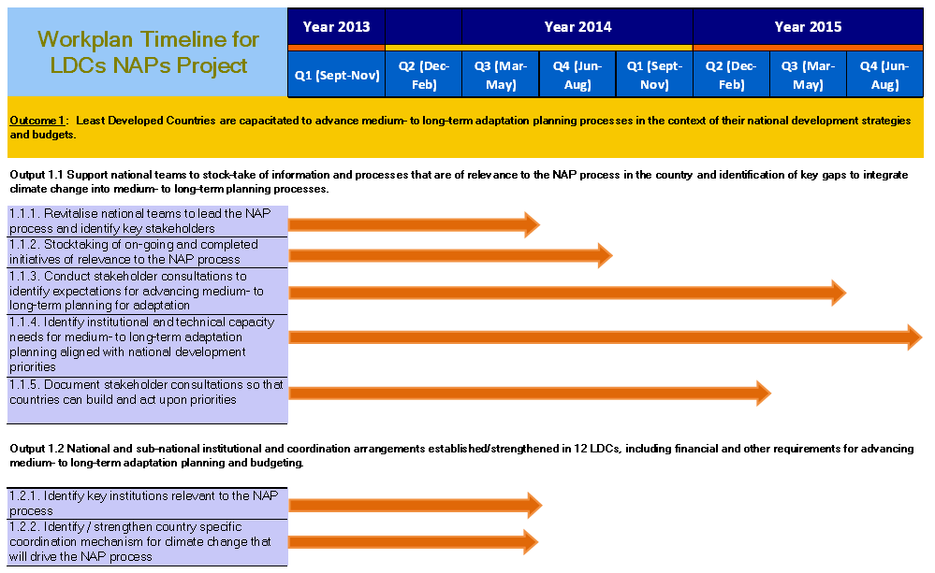
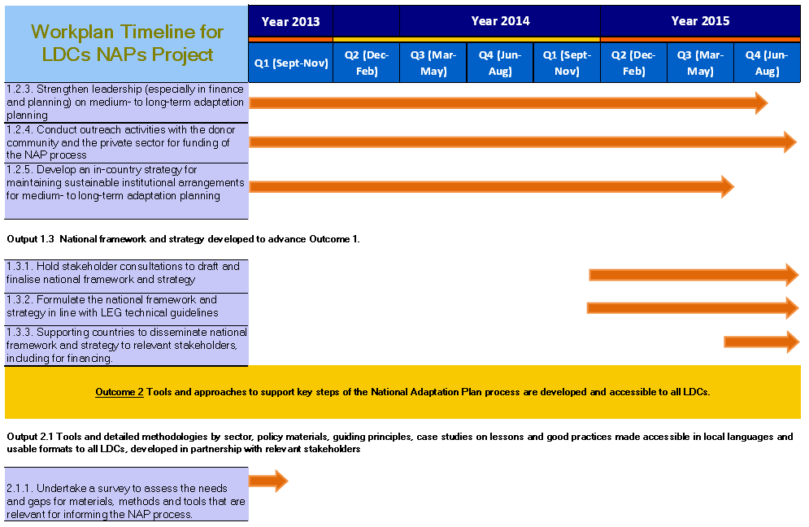
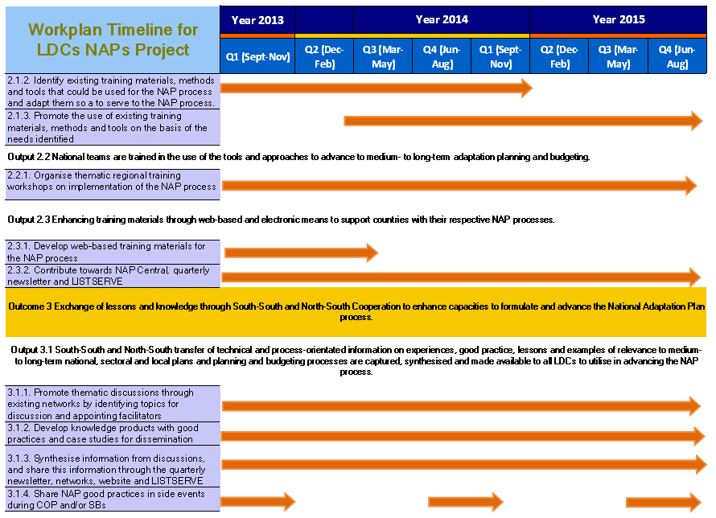

ANNEX II
Excerpt of e-mail outlining countries requesting support on NAP process and views from a bilateral agency (GIZ)

***********************************************************************************
Angola: The Angolan participants have identified the following priority
- Capacity gap analysis
- Capacity building
- Establishment of a multistakeholders national planning commission
- Establishing a vision and mandate for the NAP
- Stocktaking of available information on risk and vulnerability and identify the gap in term of information required for the NAP process
- Raising awareness of decision makers and support a high-level commitment and will to make easy the elaboration and adoption of the NAP Vision and mandate

Gambia: The Gambia is developing currently a Green LECRDS and the objective is to anchor the climate change policies and strategies on this GLECRDS. For the purpose of a success of the Adaptation long term planning, they need to strengthen their capacity of the National and sectorial planning institutions in mainstreaming climate change adaptation in development strategies and plan budgeting processes and tracking (through the establishment of climate change adaptation and mitigation budget codes). This latter will be supported by the implementation of a CPEIR for which they have asked UNDP support. To support all these initiatives, the priority elements of support under this NAP process for the Gambian participants are:
- The national capacity assessment for climate risk and vulnerability assessment, mainstreaming CC-A in policies, budgeting processes and the elaboration of a capacity development program;
- The coordination and the harmonization of all the current initiatives supporting the medium and long term adaptation planning
- raising awareness of decision making about the relevance of the NAP process and organizing a High level panel for discussing the NAP process, adopting the vision and the mandate for the NAP process as the GLECRDS currently under development;
- Development of a mandate and a vision for the NAP process;
- Compiling and completing the existing climate risks and vulnerability assessments (through LDCF projects and the EU project).

Eritrea: The Eritrean participants have identified the following priorities
- Establishment of a multistakeholders national planning mechanism
- Establishing a vision and mandate for the NAP
- Stocktaking of available information on risk and vulnerability and identify the gap in term of information required for the NAP process
- Raising awareness of decision makers about the relevance of the NAP process
- Develop a national M&E and reporting system

Liberia: The Liberian representatives have identified the following priority for the NAP process support:
- Capacity gap analysis
- Capacity building for the success of
- Establishment of a multistakeholders national planning commission
- Establishing a vision and mandate for the NAP
- Stocktaking of available information on risk and vulnerability and identify the gap in term of information required for the NAP process
- Raising awareness of decision makers and support a high-level commitment and will to make easy the elaboration and adoption of the NAP Vision and mandate
Somalia: The Somalian participants have stressed the fact that their NAPA has been recently approved, and they would like to concentrate on the implementation of the NAPA priorities. But I informed that the implementation of the NAPA and the development of NAP are not mutually exclusive processes and can be implemented on the same time. In this perspective, they have raised the following priorities
- Develop mechanisms and strategies that will allow them to coordinate the implementation of the NAPA priorities and the NAP process. I suggested them to see how to include elements for the long term adaptation planning in the implementation of the priority adaptation needs through the NAPA projects .
- Identify and fill the gaps in term of capacity for enhancing resilience and reducing vulnerability to climate change in the country
- Establishment of a multistakeholders national climate change adaptation committee that could coordinate in the future the NAP process
- Establishing a vision and mandate for the NAP
- Stocktaking of available information on risk and vulnerability and identify the gap in term of information required for the NAP process
- Raising awareness of decision makers about the relevance and the requirements for the NAP process for them to support the development of the institutional and policy framework for the successful elaboration and the continuous implementation of the NAP
Most of the other countries approached (Zambia, Soudan, Zimbabwe, Botswana, Mozambique, Tanzania, Sierra Leone) have promised to reveal their priority needs through the survey.

Discussion with GIZ
UNDP and UNEP had a discussion with the GIZ representative on their interest to participate in the implementation of the NAP GSP and how they could participate in this process. According to the GIZ representative (Till Below), the GIZ has elaborated interesting tools that could support the NAP process and they would be interested in supporting the use of these tools in countries where they have a program to support the NAP process. One of these tools is the SNAP (Smart National Adaptation Planning tool). The SNAP is a tool mainly in support for the element A of the NAP process (Lay the background and address the gap). It is assessing within the country the 7 key elements success factors for a successful NAP process: 1) the level of access to relevant climate information; 2) the human and institutional capacity within the country; 3) the existence of a long term vision and mandate for the NAP within the country; 4) the quality and quantity of strategic orientation and measures to enhance resilience or reduce vulnerability to climate change in the country; 5) the state or level of existing processes for mainstreaming adaptation into development processes at all levels; 6) the capacity of existing multi-level participation processes or mechanisms to promote wide participation in the PAN process; 7) the National M&E system capacity to monitor and evaluate the NAP process. The results of the assessment through the implementation of the SNAP exercise will be translated in a road map for the development of the NAP process.

They will be piloting this tool in Mauritania during the next months and Burundi is also interesting to test this tool. After the piloting, they will use the SNAP tool in the other country where they have a Program. Among these countries 2 have already been identified: Togo and Tunisia. The other ones will be identified in the next months. The results of the SNAP assessments will be put at the disposal of interested stakeholders and UNDP/UNEP could use them in the framework of the NAP Process. They are also ready to provide support for the technical review (through their experts) of the NAP GSP tools and guidelines and also exchange their tools they currently have with the NAP GSP.

They have also a country support facility in Asia that could also support the NAP process in Asian countries.

Annex III: 17 LDCs that have requested GSP NAP support

As of June 2013, the seventeen LDCs listed below have formally requested GSP NAP support.

- Bangladesh
- Benin
- Burkina Faso
- Cambodia
- Comoros
- Congo (DRC)
- Djibouti
- Gambia
- Lesotho
- Malawi
- Mali
- Mauritania
- Mozambique
- Niger
- Rwanda
- Sudan
- Tanzania

ANNEX IV: First Project Board Meeting Agenda

DAY ONE - Friday, 16 August 2013
9:00–10:30 - Session I (Tea/Coffee will be available)

- Opening session and adoption of the agenda

The meeting will be opened and co-chaired by UNEP and UNDP. Following the opening by the co-chairs, a discussion to agree on the agenda for the open meeting with the agencies will take place. If requested and possible, agencies not able to travel to Bangkok can connect via telephone or video to participate in the meeting.

- Implementation status of the project and update by other Board Members

Update from the project implementing agencies- UNEP and UNDP on the progress made to date on operationalizing the project following GEF approval and implementation arrangements in place/taking shape for the project.
Updates by the partnering agencies on matters of relevance to the objective of the LDCF financed NAP GSP project.

- 1st Review of the draft work plan
Review and discussion of a draft work plan based on the approved project document, country requests that have come in and taking into account planned activities of other agencies/partners. Major gaps will be identified at this stage for addressing in session 2 and 3 of the Board Meeting.

10.45-12.00 Session II

- Results of the survey on country specific needs for advancing NAPs as well as other requests for assistance by LDCs
A presentation of the results from the recently concluded survey that aimed to assess country specific needs.

Insights from the survey and country specific requests will be discussed in the context of planning for the scope of activities to be conducted by the project in pilot countries. These points of discussion will then, where relevant, be included in the workplan

12:00–13:30: LUNCH BREAK

13:30–16:00 - Session III

13.30-16.00

- Presentations from partnering organisations

An invitation to partnering organisations to give an update on their activities and map out the progress made by them thus far so that we may marry/align the activities of the project with those highlighted by them. Those agencies that are not able to attend can connect via telecon.
List of presentations include:
13.30 – 14.00;
- GIZ – Till Below, GIZ (connected via Skype)
14.00 – 14.30;
- USAID ADAPT Asia-Pacific - Name TBC
14.30 – 15.00
- UNEP/WCMC (Ole Vestergaard and Robert Monrooe)
15.00 - 1530
- LEG – Perpetua Latasi, LEG Chair
15.30-16.00
- PROVIA – Richard Klein, SEI

16.00-17.30:
- Selection of pilot countries
UNEP and UNDP to present to the board the seventeen countries that have formally requested to take part in the project as a pilot country. The project document refers to at least twelve countries.
Action:
Board members to review list of countries and decide on number and final list of pilot countries.

- Review recommendations that need to be taken into account in finalizing the work plan

Based on issues discussed in day 1, agreement on key issues that should be translated into activities in Year 1 and Year 2 of the workplan of the LDCF financed NAP project.

DAY TWO – Saturday 17 August 2013
9:00 – 12:00 – Session IV

- Review and adoption of project work-plan

Action:
A second review of the workplan based on discussions that took place in Day 1. The project board to agree on the project activities to be executed between in quarterly basis for the whole project duration as well as between now and December 2013

12:00 – 14:00 – Session V

- Next steps and AOB

- Update on UNDP and UNEP plans with supporting LDCs to address Other Elements of the LDC Work Programme (which is of relevance to the NAPs)
- Planning Event for Poland COP
- Wrapping up and closing remarks by Board Members

List of countries that requested assistance is provided as reference in Annex III. The letters will be made available on Adaptation Learning Mechanism at (http://www.adaptationlearning.net/).
Agenda is provided as reference in Annex IV.
http://www.aideffectiveness.org/images/stories/cpeir%20samoa%20content_for%20web.pdf
Objective of NAP GSP project is to assist partner countries arrive at a strategy to develop their National Adaptation Plans. As such, “NAP papers” here refers to national framework and strategy towards the development of a NAP and not the NAP itself. As requested by board members from the first project board meeting for NAP GSP, the term has been revised to read “national framework and strategy.”

